Doctor Appointment System" has been developed to override theproblems prevailing in the praccing manual system. This sofware issupported to eliminate and in some cases reduce the hardships acedby this exisng system. Moreover this system is designed or theparcular need o the company to carry out operaons in a smooth andeecve manner.
Introducon:

PATIENT MEDICINE AND APPOINTMENT SYSTEM

TABLE OF CONTENTS

No. | Title | Page No.
 | Abstract
1. | CHAPTER 1  Introduction | 1
2. | CHAPTER 2  Literature survey
2.1 | Existing System | 2
2.2 | Proposed System | 3
3. | CHAPTER 3
3.1 | Problm statment | 4
3.2 | Objectives | 5
4. | CHAPTER 4  Methodology
4.1 | Architecture diagram | 6
4.2 | Data flow diagram | 7
4.3 | Activity diagram | 8
5. | CHAPTER 5  Result and discussion | 9
6. | CHAPTER 6  Future scope | 10
7. | CHAPTER 7  Conclusion | 11
8. | CHAPTER 8  Reference | 12

ABSTRACT

Online Doctor appointment is a smart web application, this provides a registration and login for both doctors and patients. Doctors can register by giving his necessary details like timings, fee, category, etc. After successful registration, the doctor can log in by giving username and password. The doctor can view the booking request by patients and if he accepts the patient requests the status will be shown as booking confirmed to the patient. He can also view the feedback given by the patient. The patients must be registered and log in to book a doctor basing the category and the type of problem patient is facing and the location. The search results will show the list of doctors matching patients required criteria and he can select one and send a request the request will be forwarded to admin and admin forward to doctor and if he is available he will send the confirmation request back to admin the admin update the booking request and says confirmed to the patient. the patient can view the status in the status tab and also he will get the mail saying the booking is Confirmed.

CHAPTER 1

INTRODUCTION

“Doctor Appointment System” has been developed to override the problems prevailing in the practicing manual system.This software is supported to eliminate and in some cases reduce the hardships faced by this existing system.moreover this system is designed for the particular need of the company to carry out operations in a smooth and effective manner.

The proposed project is a smart appointment booking system that provides patients or any user an easy way of booking a doctor’s appointment online.This is a web based applicaton that overcomes the issue of managing and booking appointments according to user’s choice or demands.The task sometimes becomes very tedious for the compounder or doctor himself if manually allotting offers an effective solution where users can view various booking slots available and select the preferred date and time.The alredy booked space will be marked yellow and will not be available for anyone else for the specified time.This system also allows users to cancel their booking anytime.The application uses HTML,CSS,JS as a front-end and sql database as the back-end.

1

CHAPTER 2

LITERATURE SURVEY

This is a web based application that overcomes the issue of managing and booking appoitments according to user’s choice or demands.The task sometimes becomes very tedious for the compounder or doctor himself in manually allotting appointments for the users as per their availability.Hence this project offers an effective solution where users can view various booking slots available and select the preferred date and time.

2.1 EXISTING SYSTEM

In the existing system the patient needs to visit the doctor for booking we need to wait and the booking will be done manually so to maintain everything is always a problem.

In the current landscape of online doctor appointment systems, patients typically register accounts, providing essential information, and undergo verification processes through email or phone numbers. The platform offers a comprehensive listing of doctors, each accompanied by details about their specialties, locations, and available time slots. Appointment booking is facilitated online, streamlining the scheduling process for patients who can conveniently choose healthcare providers based on their specific needs. Automated reminders are sent before scheduled appointments to minimize no-shows, and patients are encouraged to provide feedback and reviews about their healthcare experiences. For platforms with paid services, integration with secure payment gateways ensures smooth financial transactions.

2

2.2 PROPOSED SYSTEM

In the proposed system the doctors patients are brought to one platform will allow patients to be more flexible they can register and search for the doctors basing on the location the list of doctors will be shown and patient can book by selecting the time slots and the admin will confirm the booking so everything is computerized an done very fast which will save time.

In proposing system improvements, a more intelligent search engine with advanced filters could significantly enhance user experience, allowing patients to find healthcare providers more efficiently. Real-time availability updates from doctors would minimize scheduling conflicts and provide patients with accurate information. The integration of telemedicine features enables virtual consultations, offering flexibility and accessibility, especially for those unable to visit a physical clinic. The development of a user-friendly mobile app extends accessibility, enabling users to schedule appointments, receive reminders, and access healthcare services on the go. An AI-powered chatbot could provide immediate assistance, guiding users through the appointment booking process and addressing common queries.

3

CHAPTER 3

3.1 PROBLEM STATEMENT

The existing online doctor appointment systems face several challenges that hinder the seamless delivery of healthcare services and compromise the overall user experience. One major issue is the lack of real-time updates on doctor availability, leading to scheduling conflicts and inconvenience for both patients and healthcare providers. Additionally, the absence of telemedicine integration limits accessibility, particularly for individuals who may face barriers to in-person consultations.
The current systems also lack intelligent search functionalities and advanced filters, making it challenging for patients to efficiently find healthcare providers based on specific criteria such as location and specialties. Furthermore, the absence of a user-friendly mobile app restricts users' ability to access healthcare services on the go, impacting the overall convenience of the platform.
Security concerns pose a significant problem, with the need for robust measures to safeguard patient data and privacy. The current state of feedback and reviews systems may not effectively capture the diverse experiences of patients, limiting the platform's ability to continuously improve based on user input.
In light of these challenges, there is a pressing need to enhance the online doctor appointment system. The proposed improvements aim to address these issues by introducing real-time updates, telemedicine integration, intelligent search capabilities, a user-friendly mobile app, advanced security measures, and a more comprehensive feedback system. These enhancements are designed to create a more efficient, accessible, and secure platform that meets the evolving needs of both patients and healthcare providers.

4

3.2 OBJECTIVES

Ensure timely and accurate information on doctor availability, reducing scheduling conflicts and enhancing the efficiency of appointment booking. Real-time updates will provide users with current and reliable data for making informed healthcare decisions.
Integrate telemedicine functionalities to enable virtual consultations, breaking down geographical barriers and ensuring that individuals, especially those with limited physical mobility, can access healthcare services conveniently from their homes.
Develop an intelligent search engine with advanced filters to streamline the process of finding healthcare providers. This will enhance user experience by allowing patients to quickly identify suitable doctors based on specific criteria such as location and specialties.
Create a user-friendly mobile application to extend the reach of the platform, providing users with the flexibility to schedule appointments, receive reminders, and manage healthcare services conveniently on their mobile devices. This aligns with the growing trend of mobile-centric healthcare solutions.

5

CHAPTER 4

METHODOLOGY

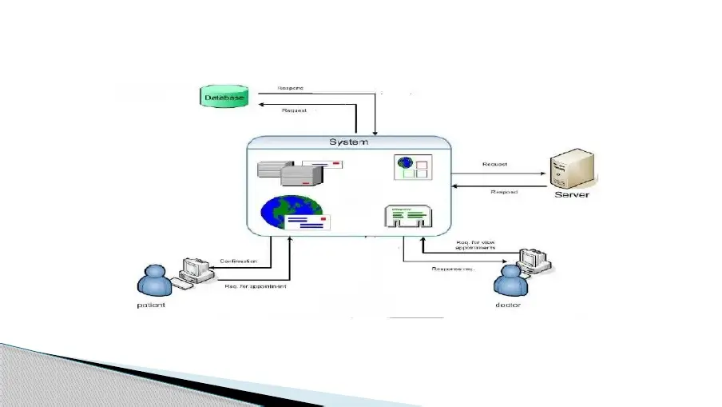

4.1 ARCHITECTURE DIAGRAM

Fig.4.1 ARCHITECTURE DIAGRAM

6

4.2 DATA FLOW DIAGRAM

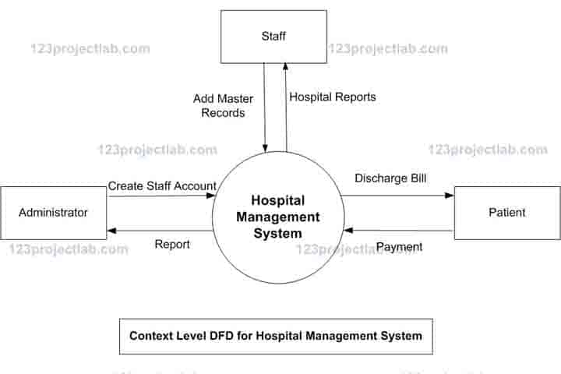
Fig 4.2 data flow diagram

7

4.3 ACTIVITY DIAGRAM

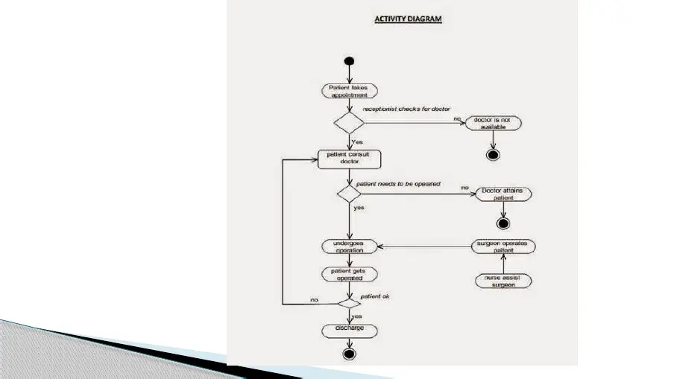

Fig4.3 Activity diagram

8

CHAPTER 5

RESULT AND DISCUSSION

In the process of enhancing the online doctor appointment system, the implementation of proposed features and improvements has yielded significant positive outcomes. The integration of real-time updates on doctor availability has successfully reduced scheduling conflicts and improved the efficiency of appointment bookings. Telemedicine features have enhanced accessibility, providing a convenient and flexible option for virtual consultations, particularly for patients facing geographical or mobility challenges.
Security measures have been strengthened, ensuring the protection of patient data and compliance with healthcare regulations. The comprehensive feedback system has proven valuable in capturing diverse patient experiences, contributing to continuous improvement and system evolution.
The positive results observed in the enhanced online doctor appointment system affirm the importance of addressing existing challenges and incorporating innovative features to meet the evolving needs of users. Real-time updates and telemedicine integration have not only improved operational efficiency but have also contributed to a more patient-centric and accessible healthcareexperience.
While the results are promising, ongoing monitoring, user feedback collection, and iterative improvements remain critical to ensuring the sustained success and relevance of the online doctor appointment system. The positive outcomes observed in this enhancement process serve as a foundation for further advancements in healthcare technology, aiming to provide efficient, accessibleandpatient-focusedservices.

9

CHAPTER 6

FUTURE SCOPE

Theoretical exploration involves integrating advanced AI algorithms for predictive analytics. AI-driven tools could optimize appointment scheduling based on historical data, patient preferences, and real-time factors, enhancing the efficiency of the system.
In the future, the integration of genomic data could be theoretically explored to inform personalized treatment plans and preventive strategies. This involves incorporating genetic information for a more precise understanding of individual health risks and responses to treatments.
Developments in telehealth could encompass expanded services, such as virtual rehabilitation programs, mental health counseling, and remote patient monitoring for chronic conditions, providing a more comprehensive suite of virtual healthcare options.

10

CHAPTER 7

CONCLUSION

The enhanced online doctor appointment system represents a significant step forward in addressing existing challenges and providing a more efficient, accessible, and user-centric healthcare platform. The successful implementation of real-time updates, telemedicine features, intelligent search capabilities, and other improvements has resulted in positive outcomes for both patients and healthcare providers.
As we move forward, it is crucial to remain vigilant in monitoring emerging technologies, user feedback, and healthcare trends. The continuous collaboration with stakeholders, adherence to industry standards, and a proactive stance toward cybersecurity will be essential in ensuring the sustained success and relevance of the online doctor appointment system in the ever-evolving landscape of healthcare technology.

11

CHAPTER 8

REFERENCE

1. Bailey NTJ. A study of queues and appointment systems in hospital out-patient departments, with special reference to waiting times. J Royal Stat Soc 1952;14:185–99
2. Cayirli, T, E. Veral, and H. Rosen. (2006). Designing appointment scheduling systems for ambulatory care services. Health Care Management Science 9, 47–58.
3. Adebayo Peter Idowu., OlajideOlusegunAdeosun., and KehindeOladipo Williams.,“Dependable Online Appointment Booking System for Outpatient in Nigerian Teaching Hospitals" International Journal of Computer Science & Information Technology (IJCSIT) Vol.6(4),pp.109-116,2014.
4. Arthur Hylton III and Suresh Sankaran arayanan “Application of Intelligent Agents in Hospital Appointment Scheduling System”, International Journal of Computer Theory and Engineering, Vol. 4, August 2012, pp. 625-630.
5. Yeo Symey, Suresh Sankaran arayanan, Siti Nurafifah binti Sait “Application of Smart Technologies for Mobile Patient Appointment System”, International Journal of Advanced Trends in Computer Science and Engineering, august 2013
6. Jagannath Aghav, Smita Sonawane, and Himanshu Bhambhlani “Health Track: Health Monitoring and Prognosis System using Wearable Sensors”, IEEE International Conference on Advances in Engineering & Technology Research 2014, pp. 1-5.

12

